**Forum:** Special Conference on Southeast and Central Asia

**Issue:** Measures to address the Kashmir Conflict

**Student Officer:** Chae Won Park

**Position:** Chair of Special Conference

Introduction

Kashmir has been the center of conflict between India and Pakistan ever since the two nations earned their independence in 1947. Britain’s 1947 Indian Independence Act had removed British presence from the Indian subcontinent and partitioned it into a Hindu India and a Muslim Pakistan. The region Kashmir was free to join either nation. In late 1947, Kashmir chose to unite with India, which gave rise to a 70-year period of small conflicts and skirmishes between India and Pakistan.

Three nations – India, Pakistan, and China – all claim to have control over the Kashmir region. India’s allegation to govern 45% of Kashmir, also known as the state of Jammu and Kashmir, is opposed by Pakistan, arguing that 35% of Jammu and Kashmir is governed by them. China declares to be in charge of the remaining 20%.

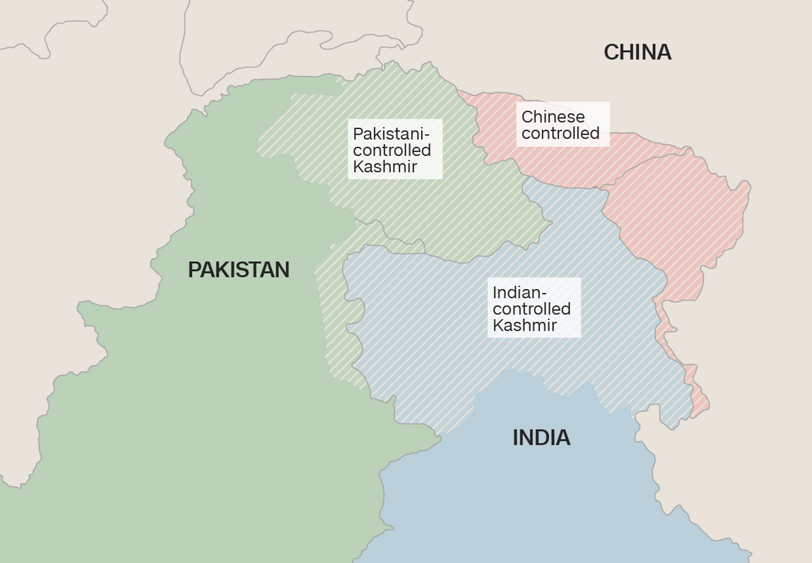Ever since 1947, there has been great tension between India and Pakistan. Constant friction exists in the region, which has escalated into two major conflicts in the past. The first war broke out in 1947 when Pakistan sent in troops into Kashmir. Accepting the petition for help, India provided Kashmir military assistance. The first conflict between the two nations came to an end after the UN called for a withdrawal of both forces. After this war, a plebiscite was put forth, which allowed for the Kashmiri people to decide their own future. The disagreement was followed by another war in 1965, but a truce was soon formed. Both India and Pakistan ratified the Tashkent Agreement the following year. However, signs of conciliation were nowhere to be seen. The violence as a result of the Kashmir Conflict has caused more than 50,000 casualties and will continue to threaten peace in the Indian subcontinent.

***Map of the current-day Indian subcontinent***

Recently, China has offered to play a role in solving the issue between India and Pakistan. India turned China’s offer down, declaring that they do not believe the intervention of a third party is necessary. This has brought about discord between the two nations over the construction of a road in the Doklam area in the Himalayan Mountains. In response to China’s plan of building a road into India’s territory, the Indian military moved in the area to halt the progress. China has continually criticized the actions of India and demanded the withdrawal of the Indian military. For the next two months, growing tension existed between the two armed forces. Fortunately, China and India reached an agreement to remove their troops from Doklam.

Water is another major reason for the conflict over Kashmir. The Indus River that flows through Kashmir is an essential natural water source for both India and Pakistan, explaining the strong desires of two nations for control over the state. Unrest in Kashmir has transformed it from a paradise for vacation, to a region of extensive chaos.

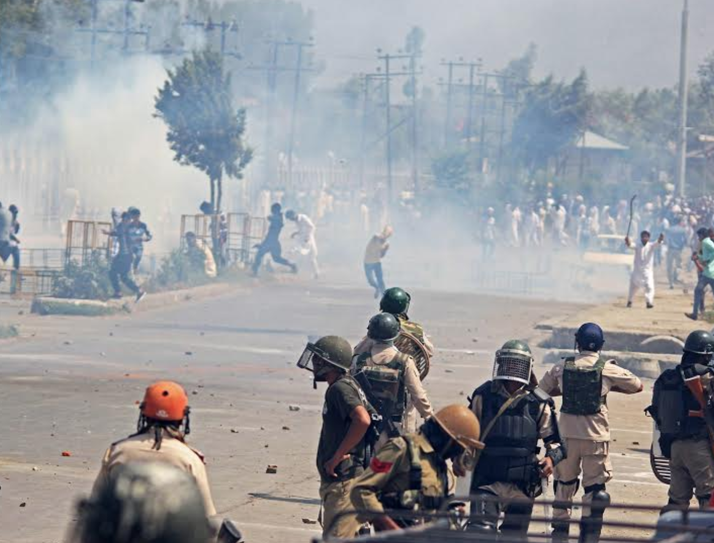Within the conflict in Kashmir also lie ethical issues. India and Pakistan have had tense clashes over authority for the state of Jammu and Kashmir, but the stances of the Kashmiri people have not been considered. The two nations try to make decisions for Kashmir without Kashmiri people’s consent, a situation clearly not burdened by ethics. While the fighting along the ceasefire line that separates India-Administered Kashmir and Pakistan-Administered Kashmir is claimed to be for the protection of the Kashmiri people, the two countries have not achieved what they have set out to do. In fact, the affair seems to be heading towards the opposite direction: huge death tolls have arisen as a result of the conflict in Kashmir.

***Violence in the state of Jammu and Kashmir***

Furthermore, among the various other factors that have led to the Kashmir conflict, valuable economic resources have also intensified the conflict. Kashmir’s economy is mostly dependent on the agriculture that is supported by its fertile land. While lumber and the raising of livestock also play a role in Kashmir’s economy, crops such as rice, corn, fruits, and vegetables are the main source of income for Kashmir. Tourism was once as important as the fertile soil and extensive plains in Kashmir. However, incessant violence and fighting in Kashmir have stopped tourists from visiting the once peaceful area.

Definition of Key Terms

Kashmir

Kashmir is, technically, a region in the northwest of the Indian subcontinent. Today, Kashmir refers to a large area that includes the state of Jammu and Kashmir controlled by India, Pakistan-controlled Northern areas, and the region of Aksai Chin controlled by China.

Jammu

Jammu is the capital city of the state of Jammu and Kashmir, the sector of Kashmir currently administered by India. The city’s hot summers and cold winters attract tourists from all over the globe.

Kashmir Conflict

The Kashmir Conflict is a territorial dispute between India and Pakistan that began in 1947, right after the partition of India. The two nations primarily have fought for the control over the state of Jammu and Kashmir.

United Nations Commissions for India and Pakistan (UNCIP)

The United Nations Commissions for India and Pakistan (UNCIP) was established on January 20th, 1948 to supervise and conciliate the Kashmir Conflict. Members of the council observe the ceasefire line and propose measures to end the conflict.

United Nations Military Observer Group in India and Pakistan (UNMOGIP)

Under the direction of the Military Advisor of UNCIP, observers of the council founded the United Nations Military Observer Group in India and Pakistan (UNMOGIP). The UNMOGIP aids the UNCIP in ending the disagreement between India and Pakistan. Recently, the group has managed to reassure each party that the other was not preparing for war, thereby reducing tension. However, the UNMOGIP has received criticism for not preventing frequent ceasefire violations. One example is the Indo-Pakistani War of 1965, when Pakistan troops illegally crossed the ceasefire line.

Karachi Agreement

The Karachi Agreement of 1949, authorized by both India and Pakistan, established a ceasefire line in the state of Jammu and Kashmir to be overseen by the United Nations Commissions for India and Pakistan (UNCIP). Formerly called the Agreement Between Military Representatives of India and Pakistan Regarding the Establishment of a Cease-Fire Line in the State of Jammu and Kashmir, the agreement was made in response to the Indo-Pakistani War of 1947. Accompanied by as many as 600 ceasefire violations in 2017, the Karachi Agreement has not proved successful.

Kashmiris

The Kashmiris are an ethnic group indigenous to the Kashmir Valley, located in the state of Jammu and Kashmir. Most Kashmiris speak Kashmiri and are religiously divided between Muslims, Hindus, and Sikhs. Ethnic and religious differences within the Kashmiri people have resulted in complications when deciding which nation to accede to after Britain’s release of the Indian subcontinent.

General Overview

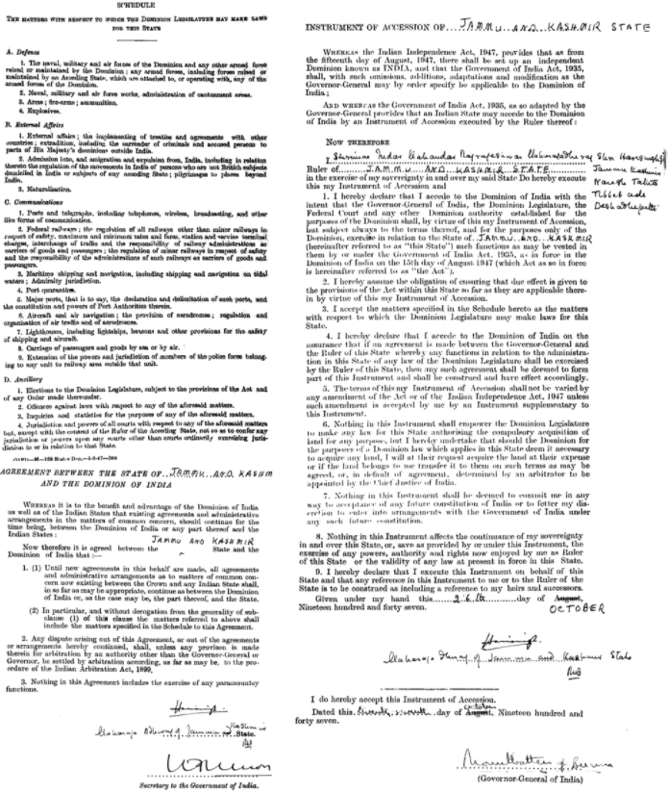The 1947 India-Pakistan partition and Kashmir

The Kashmir Conflict was initiated with the birth of Pakistan as an independent nation in 1947 after Britain’s withdrawal from the Indian subcontinent. Kashmir, a northwestern state of the Indian subcontinent, was allowed to make its own decision whether to join India, Pakistan or remain independent. Hari Singh, the prevailing monarch of Kashmir of the time, chose to remain independent. However, before long, due to attack from Pakistani forces, the ruler of Kashmir had no choice but to execute the Instrument of Accession on October 26th, 1947, which legally acceded the state of Jammu and Kashmir to the Dominion of India. As a result, India agreed to provide Kashmir with military assistance at times of danger.

***A copy of Jammu and Kashmir’s Instrument of Accession***

The Karachi agreement

After the First Kashmir War, commenced by Pakistan in an effort to acquire Kashmir, the Karachi Agreement was validated by both India and Pakistan under the guidance of United Nations (UN). The agreement declared the establishment of a ceasefire line in the state of Jammu and Kashmir, acceding two-thirds of Kashmir to the control of India and the rest to Pakistan. Since then, the issue of Jammu and Kashmir has been the core of the dispute between the two nations. Pakistan claims the state to be part of their territory because the majority of the Kashmiris are Muslim, while India insists the state should be legally under their control.

The official incorporation of Kashmir

Instead of engaging in further war with Pakistan, the Prime Minister of India, Jawaharlal Nehru, chose to submit the matter of Kashmir to the United Nations. The United Nations Commissions for India and Pakistan (UNCIP) adopted an amended version of UN Resolution 47, thereby instructing both Indian and Pakistani troops to withdraw from the state of Jammu and Kashmir. Pakistan declined the UN’s request, and the conflict continued for several months until a ceasefire was finally called on January 1st, 1949. In the following years, India repeatedly visited the United Nations regarding the issue of Kashmir. Finally, in 1957, the state of Jammu and Kashmir was officially incorporated into India. However, the authorized settlement resolved nothing.

Indo-Pakistani war of 1965

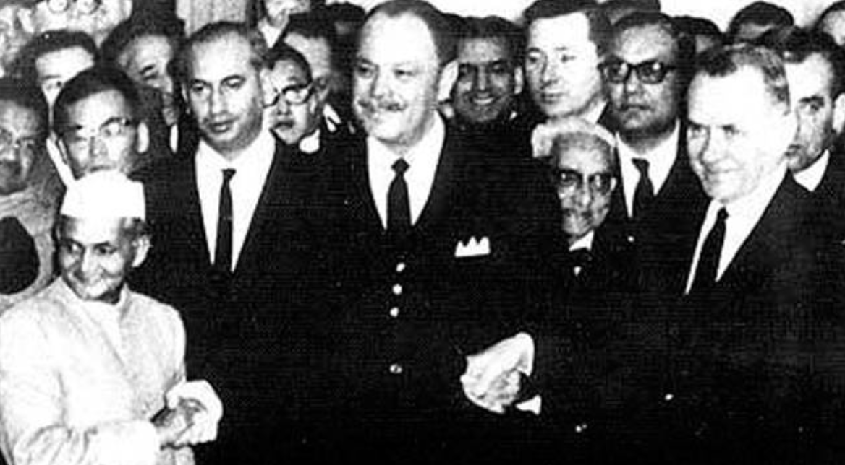War broke out again in 1965 and in a similar fashion to the 1947 war, Pakistan sent in armed forces into India-Administered Kashmir, hoping that the Muslims there would rebel against India. However, the troops were immediately captured and handed over to the Indian authorities. Indian forces reacted to Pakistan’s provocation by crossing the international border between India and Pakistan, which quickly aggravated the situation. The seventeen-day war caused thousands of casualties on both sides. Before conditions could get any worse, the United Nations supported by the United States of America (USA), Britain, and the Union of Soviet Socialist Republics (USSR) called for a prompt ceasefire. India and Pakistan authenticated an agreement in Tashkent to resolve their issues in a peaceful manner the next year, but it is undeniable that the short war bitterly impacted the people and land of Kashmir.

***The 50th anniversary of the Tashkent Pact is celebrated***

The Kargil war

War erupted again in 1999, just as Pakistani-Indian relations were improving when the Pakistani army trespassed into India-Administered Kashmir. India responded with brutal air strikes against the Pakistan forces. Both countries suffered from great economic losses, and a large number of people were forced to migrate to safer regions. With the support of the United Nations, the contemporary Pakistani Prime Minister retreated his troops, officially terminating the Kargil War. Four years later, India and Pakistan agreed to enforce a ceasefire line, thereby modifying the line to the Line of Control (LoC). Although unofficial, this military control line separates Indian-Administered Kashmir and Pakistan-Administered Kashmir. Much like the ceasefire line, the Line of Control (LoC) has not effectively occasioned peace in the area. Hundreds of ceasefire violations took place, inducing deaths of the innocent.

Damage and human rights abuse

Tourism used to be a key sector of Kashmir’s economy. Kashmir during autumn is stunning, with the region’s well-known chinar trees changing color from green to crimson and gold. The famous Mughal Gardens draw tourists from all around the globe. However, since the eruption of a Muslim rebellion against Indian forces in the early 1990s, the number of visitors rapidly declined. Tourism is not the only victim of the Kashmir conflict. In response to recurrent revokes of the Kashmiri civilians, the Indian army has arrested, raped, and tortured Muslim women. The Indian government’s neglect of human rights in the state of Jammu and Kashmir has already caused 600 deaths.

Prospects for the future

Despite efforts made by both nations to improve their rigid relationship, hopes of peace between them are not very high. Both the Karachi Agreement and Simla Agreement were rectified sanguinely. Due to recurring ceasefire violations by both nations, however, any agreements or treaties have proven to be fruitless. Cooperation between India and Pakistan appears to be indispensable in order to promptly resolve the Kashmir Conflict.

UN Involvement, Relevant Resolutions, Treaties and Events

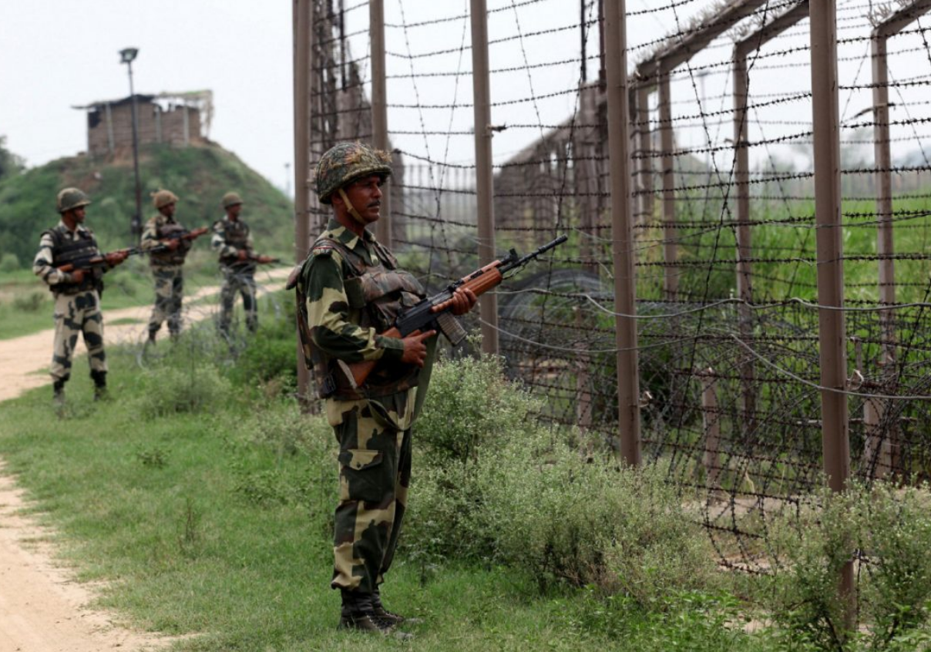Despite the United Nation’s efforts to resolve the Kashmir Conflict, there has been no successful resolution of the case. The UN has taken part in the Kashmir issue since the beginning, mediating the dispute between India and Pakistan. The UN Security Council passed Resolution 47 in 1948, which called for the suspension of hostility between the two nations and granted the state of Kashmir freedom and independence. Creation of the Plebiscite Administration ordered India and Pakistan to restore peace to Kashmir; however, these ceasefire treaties were often violated.

Under the Karachi Agreement of 1949, the ceasefire line between India and Pakistan was distinctly drawn. Although the treaty was signed by both nations and seemed effective in its early stages, there have been many violations. With a surprising number of 286 violations in just 2016, the ceasefire line in Kashmir now almost appears to be futile.

***Soldiers patrol the ceasefire line that separates India- controlled Kashmir and Pakistan-controlled Kashmir***

More resolutions to stop the Kashmir Conflict were proposed by the UN later in 1949, but due to either India or Pakistan’s rejection, many did not pass. After the state of Jammu and Kashmir decided to accede to India, brutal warfare broke out in 1965. By that time, the United Nations had grown weary of the issue, and their resolutions became much less detailed than before. In September, the UN Security Council approved three resolutions expressing its hope for the end to the Kashmir conflict and petitioning the two parties to cooperate. Recently, the Communist Party of India repudiated the United Nations as an irrelevant institution for solving the Kashmir Conflict, claiming the UN has nothing to do with the issue.

Timeline of Events

|  |  |
| --- | --- |
| **Date** | **Description of event** |
| August 14th, 1947  October 26th, 1947  April 21st, 1948  July 27th, 1949  September 1965  January 10th, 1966  May - July 1999  November 26th, 2003  2016  2017 | Britain finally renounces its 200-year control of India, dividing the country into a Hindu India and a Muslim Pakistan  Hari Singh signs the Instrument of Accession, which legally ceded the state of Jammu and Kashmir to the Indian government; in response to Kashmir’s accession, the Pakistan army proceeded to invade Kashmir and initiated the first war between India and Pakistan  The United Nations Security Council Resolution 47 is passed, but the tension between India and Pakistan does not meet its conclusion  India and Pakistan sign the Karachi Agreement, but often violates the pact  Followed by the state of Jammu and Kashmir’s acceding to India, the Indo-Pakistani War of 1965 breaks out  India and Pakistan confirm the Tashkent Declaration that resolved the Indo-Pakistani War of 1965 and temporarily restored peace in Kashmir  Pakistan forces invaded India-controlled Kashmir, initiating the Kargil War; the war was concluded with the call of the United Nations to withdraw all forces from the state of Jammu and Kashmir  Due to recurring infringements of the ceasefire line, India and Pakistan agree to enforce the line and adjust it to the Line of Control (LoC)  More than 250 ceasefire violations take place in the state of Jammu and Kashmir, bringing about numberless casualties  More than 600 ceasefire violations take place in the state of Jammu and Kashmir, bringing about numberless casualties |

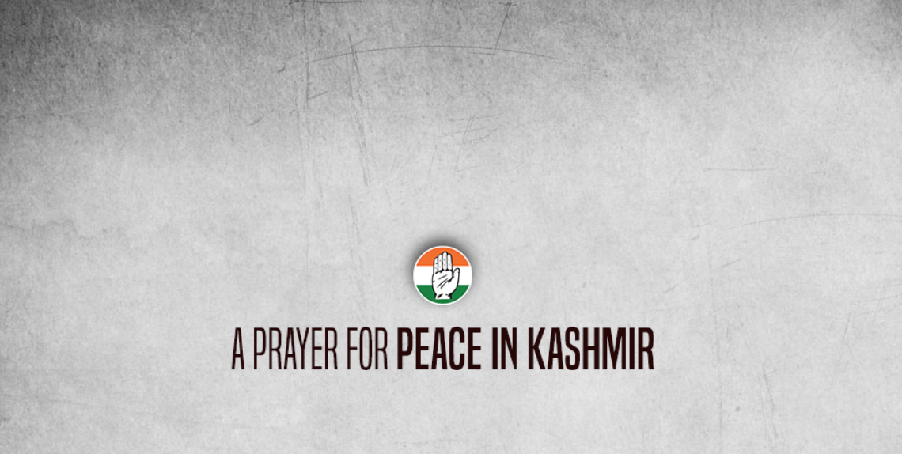Possible Solutions

***This poster implies the severity of the violence in Kashmir***

Accompanied by continual conflict, there seems to be no end to the Kashmir Conflict. In the last few years, however, both India and Pakistan have shown interest and willingness to resolve the issue together. One possible solution to the conflict is the independence of Kashmir. The idea is not completely novel, for it was first proposed by Sheikh Abdullah, a Kashmiri politician, back in 1947. Although his suggestion was immediately dismissed, Kashmir’s freedom will ameliorate violation of the Kashmiris’ human rights without a doubt. The majority of Sunni Muslims who reside in the Kashmir Valley favor the idea of independence – curfew will be lifted, military forces will stand easy, and life will return to normal.

However, not all Kashmiris are in favor of putting this plan forward. Political parties such as the Ali Gillani Group and Hizbul-Mujahideen push for accession to Pakistan, and hence refuses the idea of independence. Lack of unity on this potential solution makes it difficult to adopt.

Another option is the trusteeship of the United Nations. To resolve the Kashmir Conflict with plausibleness, the territory of dispute may be placed under control of UN for a certain period of time. After an interval of ten to twenty years, regarding the final verdict of the Kashmiris, the matter may be concluded. This plan will give the people of Kashmir, on both sides of the Line of Control (LoC), adequate time to decide their future without pressure or force from neither India nor Pakistan.

However, this alternative is not feasible until both India and Pakistan agree to withdraw their forces from the state of Jammu and Kashmir. As discussed above, India has outrageously and repeatedly refused the involvement of China and insists that the Kashmir Conflict is a bilateral issue. In the same way, India will rebuff the approach of any third party, including the United Nations.

On the other hand, it will be as equally challenging to persuade Pakistan to agree to the presence of International forces. It is likely that Pakistan authorities will be unwilling to approve the proposal because then they would have to disarm and stop militancy. Under current conditions, this solution does not seem practical as well. Building trust seems to be s fundamental step in resolving the Kashmir Conflict.

A more reasonable solution would include a win-win situation for both parties – greater economic access and opening of borders between India-controlled and Pakistan-controlled Kashmir. India will be able to retain its political control but will have to open routes and grant Pakistan economic access to Kashmir. No solution will succeed unless it is a win-win formula for both India and Pakistan. Alternatively, the Line of Control (LoC) may be made permanent. Presently, the LoC is not legal, which explains the frequent ceasefire violations by Pakistan forces. If the Line of Control (LoC) is turned into an international border, experts guarantee that tension in the region will substantially decrease.

Bibliography

Chakravarty, Ipsita. “The UN in Kashmir: A potted history of resolutions that led nowhere.” *History Revisited* Scroll.in, 26 Sep. 2016. Web. 03 Nov. 2017. <<https://scroll.in/article/817144/the-un-in-kashmir-a-potted-history-of-resolutions-that-led-nowhere>>

Tristam, Pierre. “Kashmir History and Background: How the Conflict in Kashmir Influences Policy in Afghanistan and the Middle East.” *Humanities* ThoughtCo, 02 June. 2017. Web. 20 Nov. 2017. <<https://www.thoughtco.com/kashmir-history-and-background-2353435>>

Hunt, Katie. “India and Pakistan’s Kashmir dispute: What you need to know.” *Asia* CNN, 27 Sep. 2017. Web. 03 Nov. 2017. <<http://edition.cnn.com/2016/09/30/asia/kashmir-explainer/index.html>>

Venkatachalam, K.S. “Kashmir’s Problems Need a Political Solution: A political remedy is the only long-term solution to violence in Kashmir.” *The Debate* The Diplomat, 05 Sep. 2016. Web. 20 Nov. 2017. <<https://thediplomat.com/2016/09/kashmirs-problems-need-a-political-solution/>>

Ahmad, Wajahat. “Kashmir and the United Nations.” *Kashmir* Countercurrents, 27 Aug. 2008. Web. 20 Nov. 2017. <<http://www.countercurrents.org/ahmad270808.htm>>

### Das, Nayana. “[Did United Nations Peacekeeping achieve what it set out to do?](https://unyouknow.org/2015/10/06/did-united-nations-peacekeeping-achieve-what-it-set-out-to-do/)” *You Know?!* UN, 18 Sep. 2016. Web. 20 Nov. 2017. <<https://unyouknow.org/2015/10/06/did-united-nations-peacekeeping-achieve-what-it-set-out-to-do/>>

Panda, Ankit. “The Doklam Standoff Between India and China Is Far From Over.” *The Debate* The Diplomat, 22 Oct. 2017. Web. 20 Nov. 2017. <<https://thediplomat.com/2017/10/the-doklam-standoff-between-india-and-china-is-far-from-over/>>

Hussain, Bilal. “The Economics of the Kashmir Conflict.” *Café Dissensus Everyday* Café Dissensus, 20 Feb. 2017. Web. 20 Nov. 2017. <<https://cafedissensus.com/2017/02/20/the-economics-of-the-kashmir-conflict/>>

Burke, Jason. “Indian forces in Kashmir accused of human rights abuses cover-up.” *Kashmir* theGuardian, 12 Sep. 2015. Web. 10 Dec. 2017. <<https://www.theguardian.com/world/2015/sep/12/indian-forces-kashmir-accused-human-rights-abuses-coverup>>